BlueCloud Analytics Login. MicroStrategy (sirsidynix.net)
Log on with your library user and password.
Click on BCA MANI box
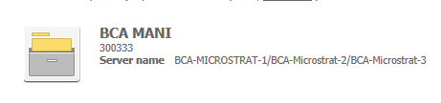
Next click on My Reports
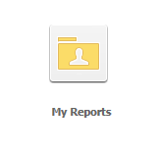
Next click on the Youth Staff Reports
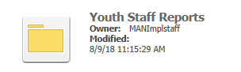
Next click on the edit under MPL youth search for PIC
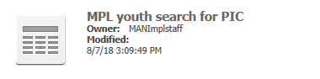
If you want to change your search word, click on the Contains “Camping”
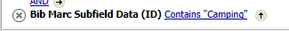
Replace the word camping with what you would like to search for
Click Apply
If you want to change the Item Type or other list, click on the list
Then the list of available options will display and you can eliminate or add other options, click on the option and use the arrows between to move from one list to the other:
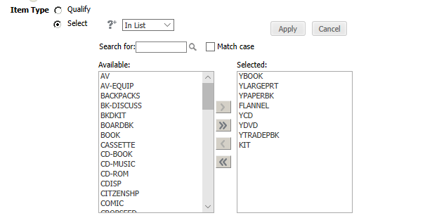

Once complete, click Apply. Then click the save button in the upper left corner or if you want to create a new report click the save as button and give the report a name. If you create a new report you will see
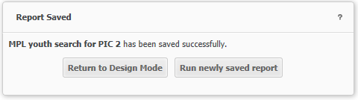
Click the Run newly saved report to run the new report or Return to Design Mode to go back to the original report.

Once complete, click the run button in the upper left corner.
Then you can export the file 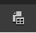 or send it to yourself.

