BlueCloud Analytics Basics
Log into BlueClouds Login. MicroStrategy (sirsidynix.net)
Click on the folder
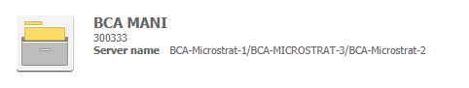
Click on My Reports to see what reports are available.
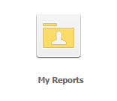

If you would like to have a folder with your reports, click on the red Create button and click on New Folder, this will create a folder that you can name for your reports.

To create a new report, Click on Create, then New Report.
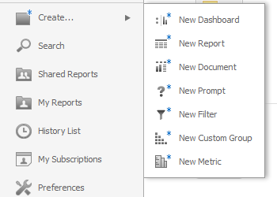
Click on Blank Report.
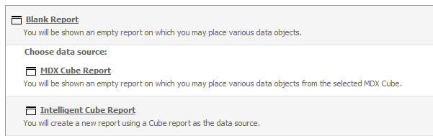
Click on Attributes
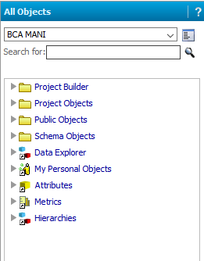

The list of data will then display. Depending on what type of report you want to create you will pick the folder for that data set.
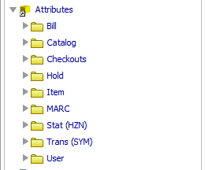
Since we have Symphony, if you want to get historical data, you will choose Trans (SYM), then Stat.
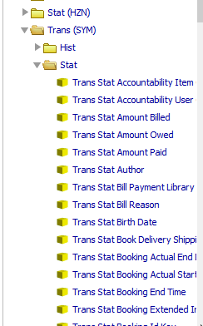

The next step will be to decide what you want to filter the report with, such as Trans Stat Station Library. Click on field and drag up to the filter box. Then you can click on the Select button and choose your library. You must use the arrow to move the library to the Selected box. The default is In List, but you can also choose Not In List. Then click on the Apply button.
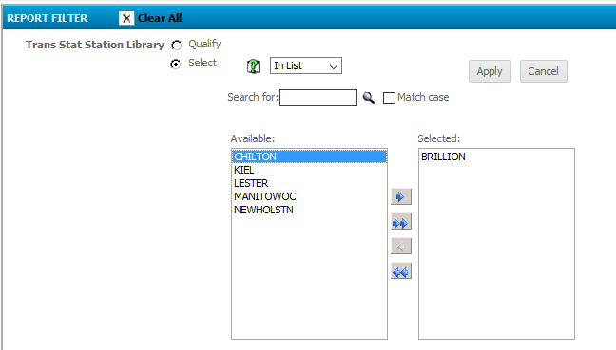
Then you can add other fields such as Trans Stat Date.
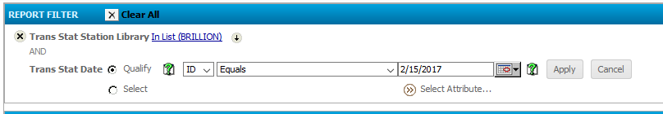
You can change the Equals to various options, such as Greater Than or Equal to. When you click on the calendar, you can choose a date or click on the Dynamic date, this is what will display:
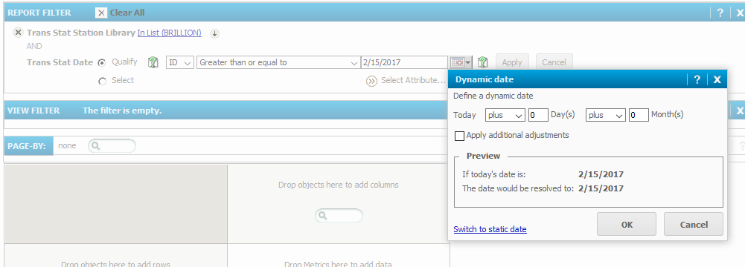

Now you can select a date range that will change dynamically. When you change the parameters the Preview box will show you the results of your changes. Click the Apply additional adjustments to choose weekly, monthly or yearly.
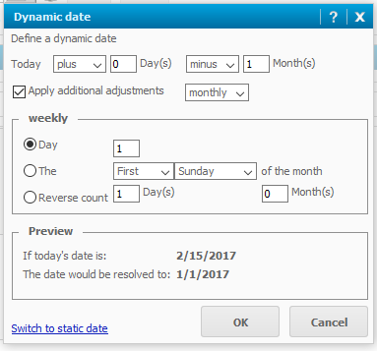
Then add another Trans Stat Date to get a date range.
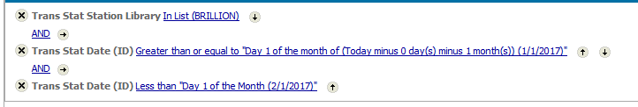

If you want to have circulation statistics, you will need to choose the Trans Stat Command Desc, to get the list of available options, click on Select and choose Charge Item Part B, Renew Item, and Renew User Part B. You must use the arrow to move the library to the Selected box. The default is In List, but you can also choose Not In List. Then click on the Apply button.

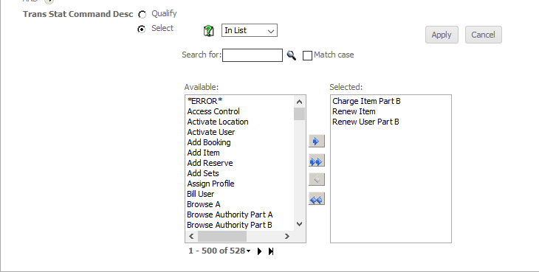

Next you will pick what you want to display in the report, such as Trans Stat Itype. Just double click on the field you want to display.
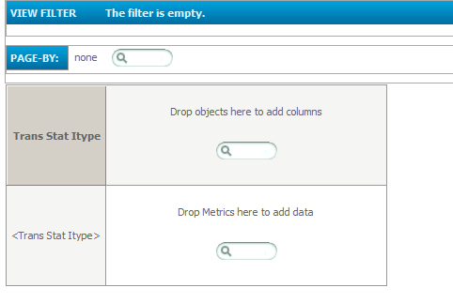

Then Click on the Metrics in the left column, Click on Trans, and then double click on Number of Statistical Transactions to add that to your report.
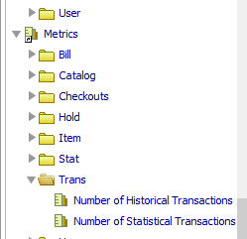
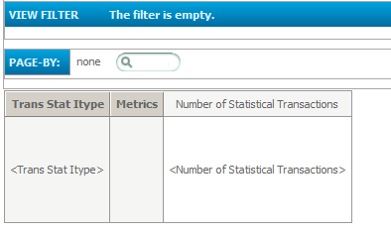

Now you can save your report to see what your results will look like.
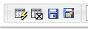
If you hover over the icons, the first one is Run Report, next is Cancel, then Save and last is Save As. The first time you want to Save As so you can name your report.
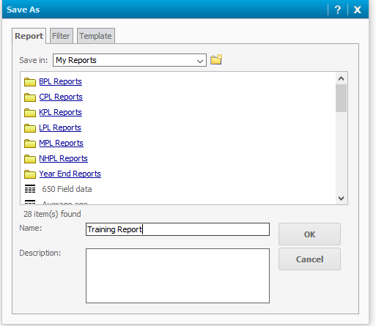
You will then be given the option to go back to design mode or run your new report.
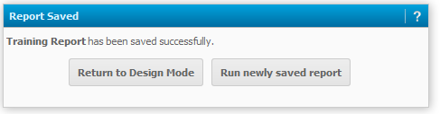
If you choose Run newly saved report your report will display.
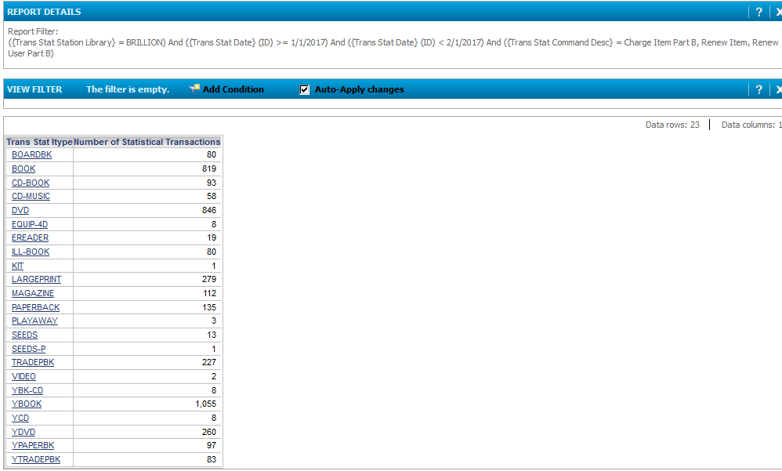
On the Home tab, you can hover over the icons to do various things, such as print, email or export.
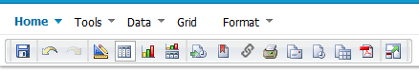
On the Data tab, you can do things like sort, totals or add additional fields or metrics.
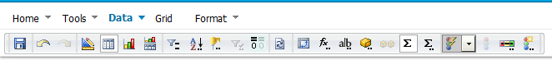
If you make any changes make sure that you click on the save icon.
If you want to export your report you will get the option to choose how you want the report to look.
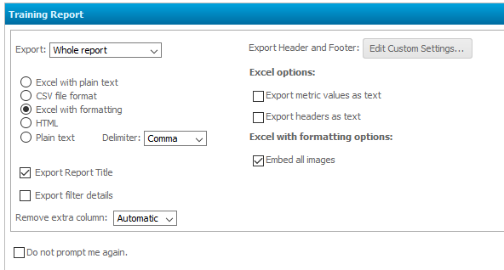
Once you choose your option click the export button and your report will display in the new format.

If you want to remove an item from report display, right click on the field and you can remove it from the grid or report.
